CALL FOR PAPERS
Special Session on ‘AI-Driven Medical Imaging: Foundations, Applications, and Clinical Translation’
2026 7th International Conference on Machine Learning and Human-Computer Interaction
Conference Website: http://mlhmi.org/
March 17-19, 2026 | Tokyo, Japan

Conference Venue: Meiji University Surugadai Campus, Tokyo, Japan
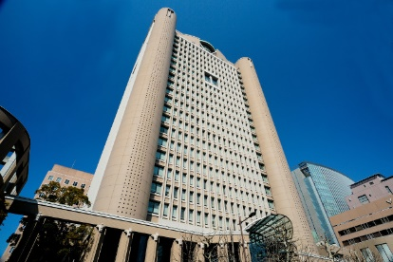
ORGANIZED AND CHAIRED by

  - Deepika Koundal, University of Eastern Finland, dkoundal@uef.fi
  - Kanika Bhalla, Washington University, St. Louis, USA, bhalla@wustl.edu

SPECIAL SESSION DESCRIPTION

Medical imaging has entered a transformative era driven by artificial intelligence (AI), enabling automated diagnosis, treatment-response prediction, multimodal fusion, and accelerated clinical workflows. Despite significant progress in deep learning, robust clinical translation remains challenging due to domain shift, limited annotated datasets, and the need for generalizable, interpretable models.
This Special Session brings together researchers working at the intersection of machine learning, medical image analysis, and human-computer interaction to present advances in imaging biomarkers, deep neural architectures, self-supervised learning, and clinically validated AI pipelines. The session will emphasize model reliability, explainability, and integration with clinical decision-making, highlighting real-world deployments across oncology, neurology, and radiology.
We welcome contributions that push the boundaries of AI-driven medical imaging—from foundational algorithms to translational studies.

TOPICS COVERED
- Deep learning methods for medical image classification, segmentation, and detection
- Multimodal fusion of imaging with clinical, genomic, and textual data
- Explainability, uncertainty quantification, and clinician-AI interaction
- Self-supervised and domain-adaptive learning for medical imaging
- Clinical translation, deployment, and validation of AI imaging systems

Schedule:
Deadline for submission of the paper (s) to the Electronic Submission System by selecting the desired special session – December 15, 2025

Supported by:

Technically Supported by

Media Partner

Published by

Indexed by:
 

